

# Earthquake Damage Visualization

**Reza Sheibani**

**Natalia Soto Viraj Rathod**

Cover/ landing page of the website.

Overview

* This project is directly related to the research interests of one of the members.
* Earthquake damage prediction is one of the most popular topics in the civil engineering community.
* Visualizing the consequences of an earthquake with an attractive design and providing information regarding the level of vulnerability of different structures is the main goal of this project.
* A dataset, describing the seismic behavior of buildings in San Francisco city during a hypothetical M7.0 earthquake is available and will be implemented in the project (Fig. 1).
* A dataset, describing the seismic behavior of buildings in San Francisco city during a hypothetical Mag. 7.0 earthquake (Fig. 1).

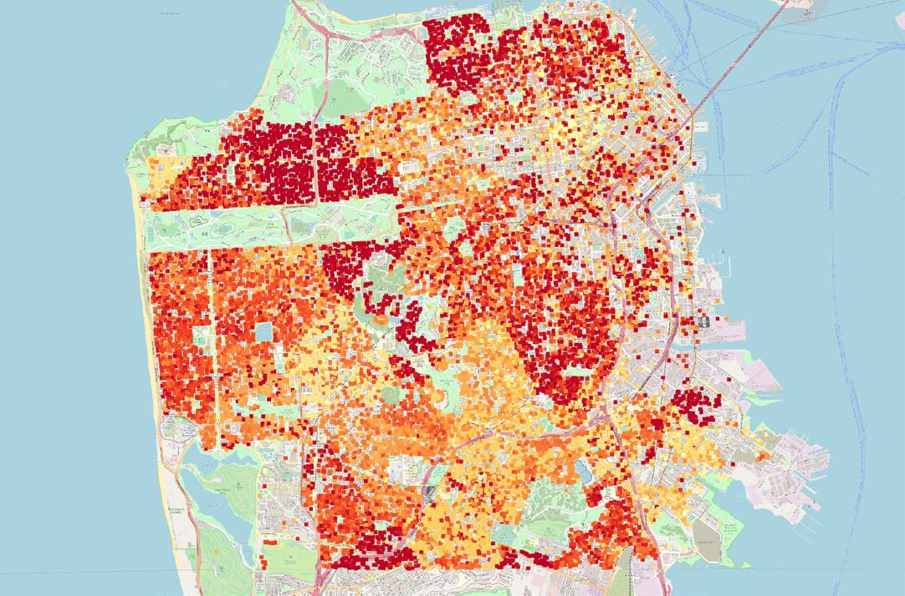

Motivation

The idea behind this visualization is to provide an idea of the damage caused by an earthquake and the repair cost associated with it.

Different factors like the area of the buildings in the area, no. of stories, type of the building, whether it is a residential or a commercial building.

One of the project members is doing his research project in this domain and visualizing the data associated with an earthquake was an extension of the idea.

Conceptually the idea is to create awareness among officials who deal with earthquakes and its causes.



**Project Process Book**

5

# Introduction

## Data

The earthquake ground motion data is generated for the Hayward fault in the Bay Area and is obtained from [1]. The building’s responses to the seismic loading are simulated by dynamic finite element analyses.

## Related Work

The simulation is studied in a collaboration between the SimCenter at NHERI [2] and one of the team member’s research group. It Is carried out on a machine which simulated a magnitude 7.0 earthquake on Richter scale. Data aggregated is visualized in our project.

## Tasks

We decided to visualize our data which consisted of several metrics related to the damage caused by the earthquake.

Like damageRatio, Area of the Building, No. of stories and more.

The structure type tells you the story behind which material stood out when during the earthquake.

## 

## Users

The target audience is the Civil Engineers, Government officials and judiciaries concerned with the safety and the well-being of the public. To appeal to the contractors who can make an informed decision about the type of material to be used, which can be based on the area of the construction or the vicinity.

It is not a live earthquake data, but just a simulation. So, it can be treated as a precautionary measure and different protocols and measures can be jotted down before an actual calamity occurs.

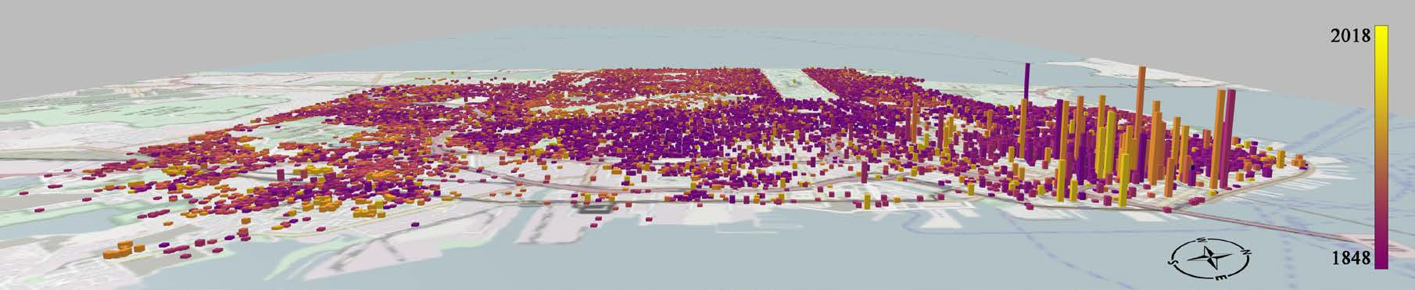

# Questions

* + How do people best visualize geographical spaces in conjunction with data?
  + What areas of San Francisco have stronger buildings than others?
  + What is the median repair cost of re-constructing buildings in the area?
  + What primary material are buildings built within different areas of San Francisco?
  + How does the building age and building material cost affect the amount of damage incurred?

# Process

## Data Processing

### Among the quantities that we will derive are:

* + - Buildings year built
    - Buildings structural type
    - Earthquake intensity at each building’s site
    - Repair cost of the building after the earthquake
    - Occurrence of collapse

Project Schedule

|  |  |  |
| --- | --- | --- |
| Action Item | Expected Date | Actual Date |
| Project Proposal | 10/25/2019 | 10/25/2019 |
| Visualization Design discussion | 10/28/2019 | 10/28/2019 |
| Completion of Visualizations phase I | 11/05/2019 | 11/07/2019 |
| Completion of Semantic zooming and optional features | 11/12/2019 | 11/15/2019 |
| Adding additional features | 11/19/2019 | 11/23/2019 |

**Visualization Design**

Sketch

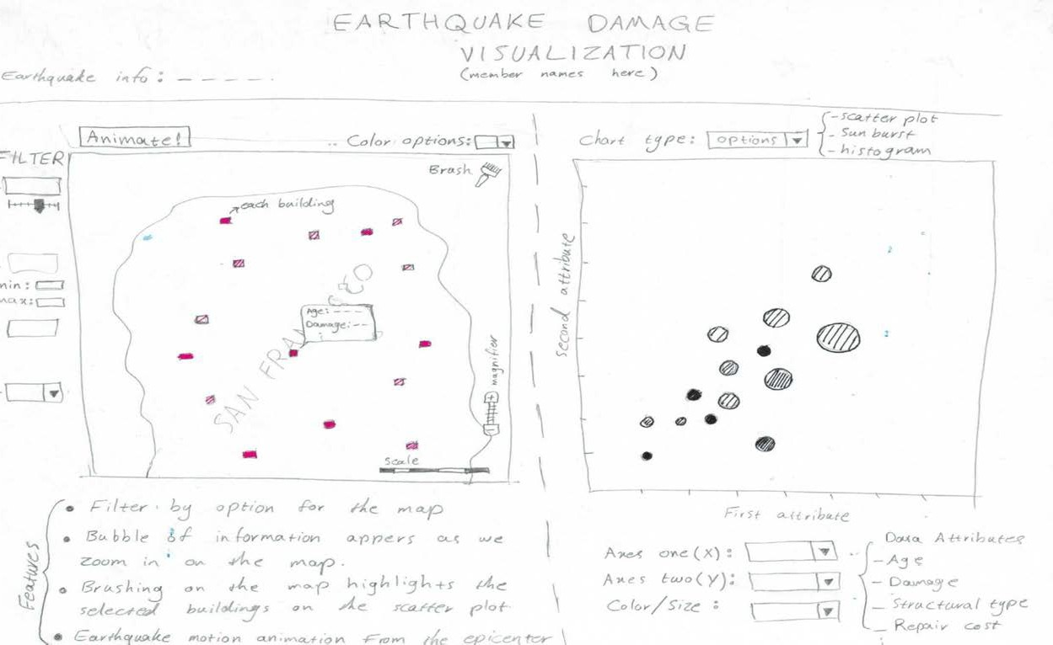

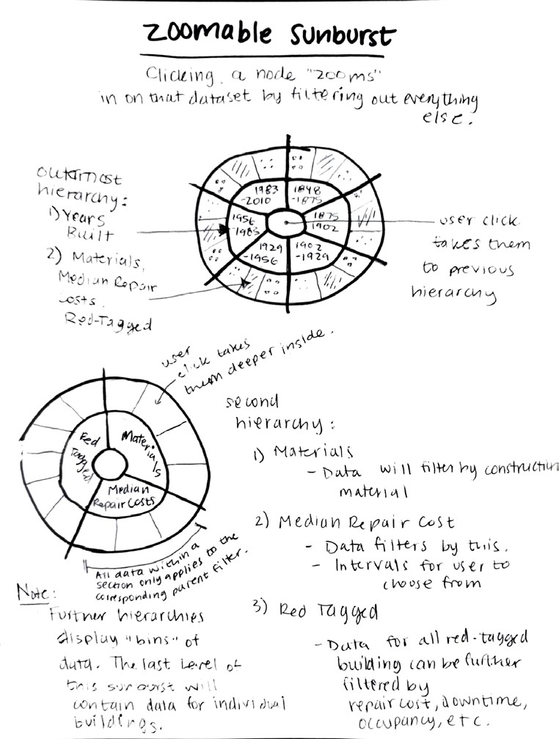

Design Evolution

Ultimately, the objective was to visualize the bins to show the sunburst view. It was decided that the most intuitive and simple method was just a sunburst connecting the Map view showing each of the bin size.

Down the line, we decided to show a scatterplot in addition to the sunburst. Additionally, an interaction between the scatterplot, Sunburst and the Map view would make things easier.

Features

### Must have features:

* Showing earthquake damage on a map for each building.
* Scatterplot: Linking the map with a scatter-plot figure to show different features of the data.
* Semantic zooming: The reason we need to have semantic zooming is to have a dedicated view window.
* Brushing: To see the data for a specific set of buildings.
* Histograms: To visualize each column through a dropdown menu.

## 

## Optional Features:

* Transitions in the scatterplots.
* The animation of the earthquake wave magnitude shows the effect emulated on the buildings.
* Visualizing averaged view on map plot to avoid high computation demand and show detailed view for each individual building in the zoom-in plot.
* Snap points scrolling

On the left side of our website, we will display at least two additional features besides our map. A sunburst filtering visualization

A scatterplot with different x and y axes to display our data.

To change between these, we plan on using a “Snap point scrolling” mechanism.



Shake text effects

Inspiration - Special CSS hover effects: [Shake effects](https://csshake.surge.sh/)



Project Peer Feedback - October 29th

Notes:

1. To add a cohesive feeling and context:

timeline

1. Add storytelling with tooltips. Point out specific buildings and the damage incurred on a

b. Have 3-4 story points that a user can navigate through

1. The animation of the earthquake wave magnitude shows the effect emulated on the buildings.
2. Zoomable sunburst feedback:
   1. Have this filter the data shown on the scatterplot simultaneously.
   2. (ex. filtering by years 1845-1875 shows only those years on the X-axis)
3. Convey a deeper meaning with the data
   1. Are rich areas less affected by the earthquake?
   2. What areas of damage were most affected?
   3. Which buildings were most quickly built?
4. Create a website with tabs to switch through datasets or visualizations.
5. Visualizing averaged view on map plot to avoid high computation demand and show detailed view for each individual building in the zoom-in plot.

Maps v2

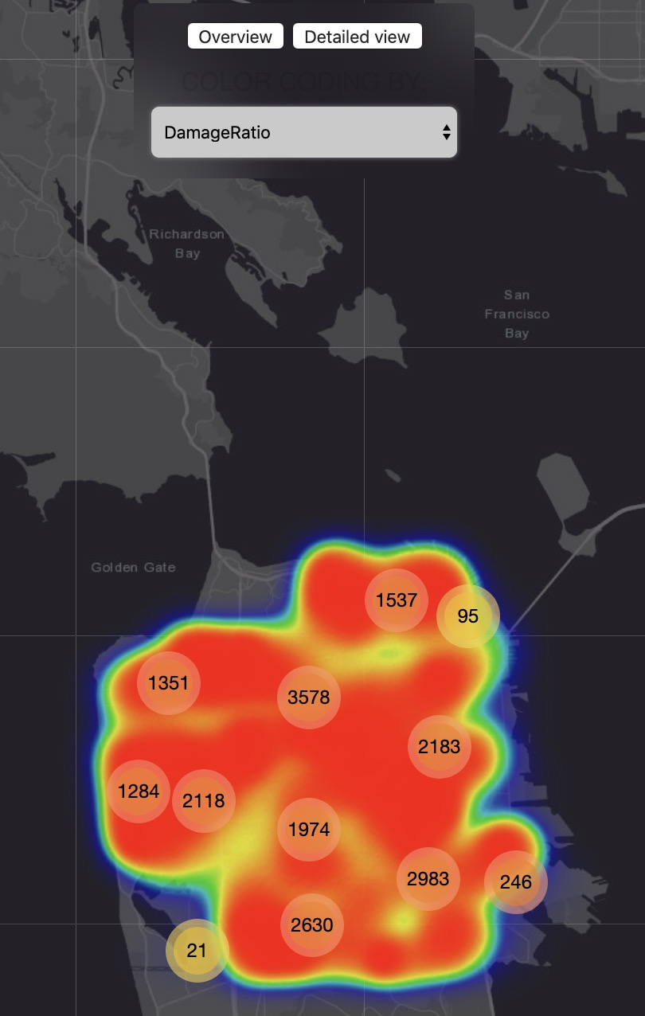The maps which visualizes the building details on a static map has two views.

The picture on the left is an overview of what the map looks like when its color-coded when an earthquake hits the city.

The damage done is shown by red – yellow, red being the areas affected the most and yellow the least.

The number on the map shows the grouped number of buildings in and around the area.

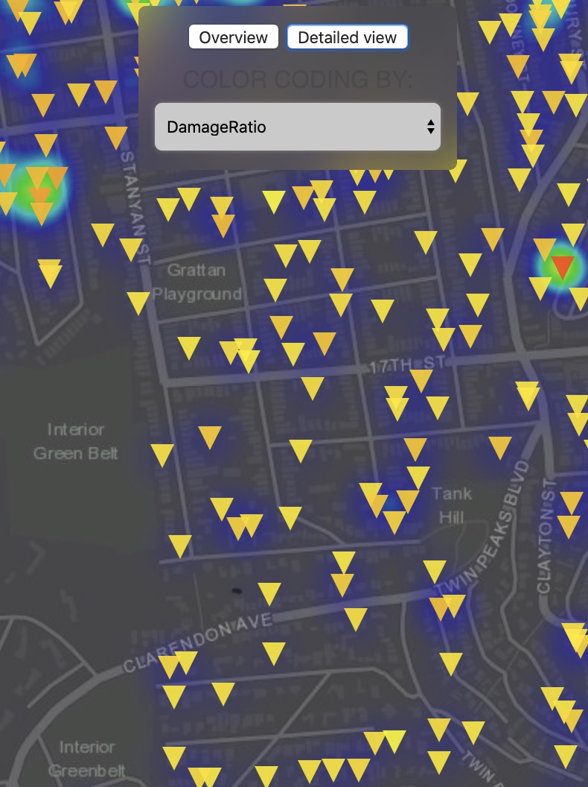

The detailed view is shown via markers on the map.

The markers essentially denote the building positions.

The color denotes the damage done to the building.

Implementation

Scatterplot v2

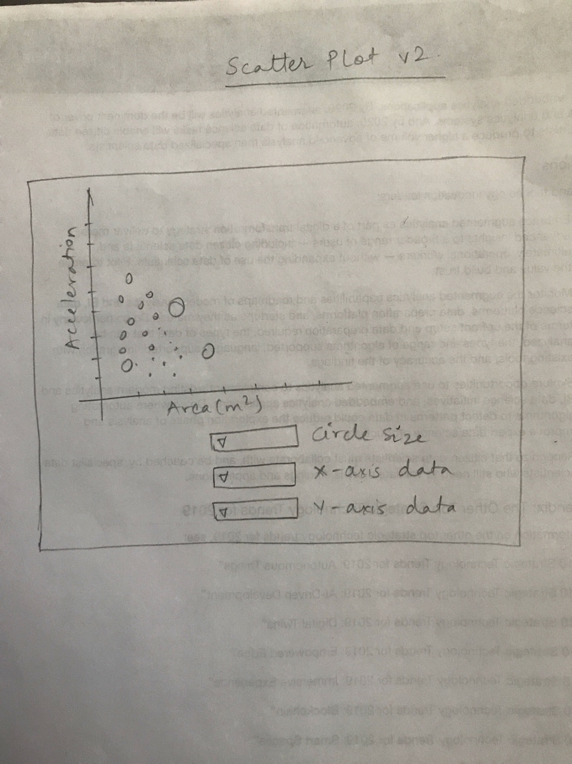A simple scatter plot to show the different entities against each other.

You can choose the different quantity from the dropdown menus below, for the circle size, x-axis and the y-axis data.

On clicking on any of the bubble you can view the data pertaining to the specific coordinates.

Project Milestone

Snapshot

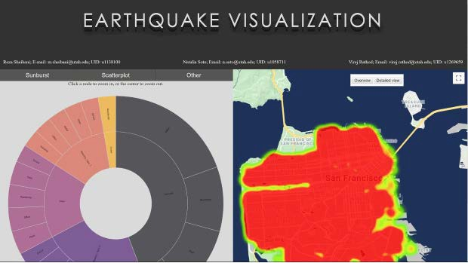

Sunburst v2

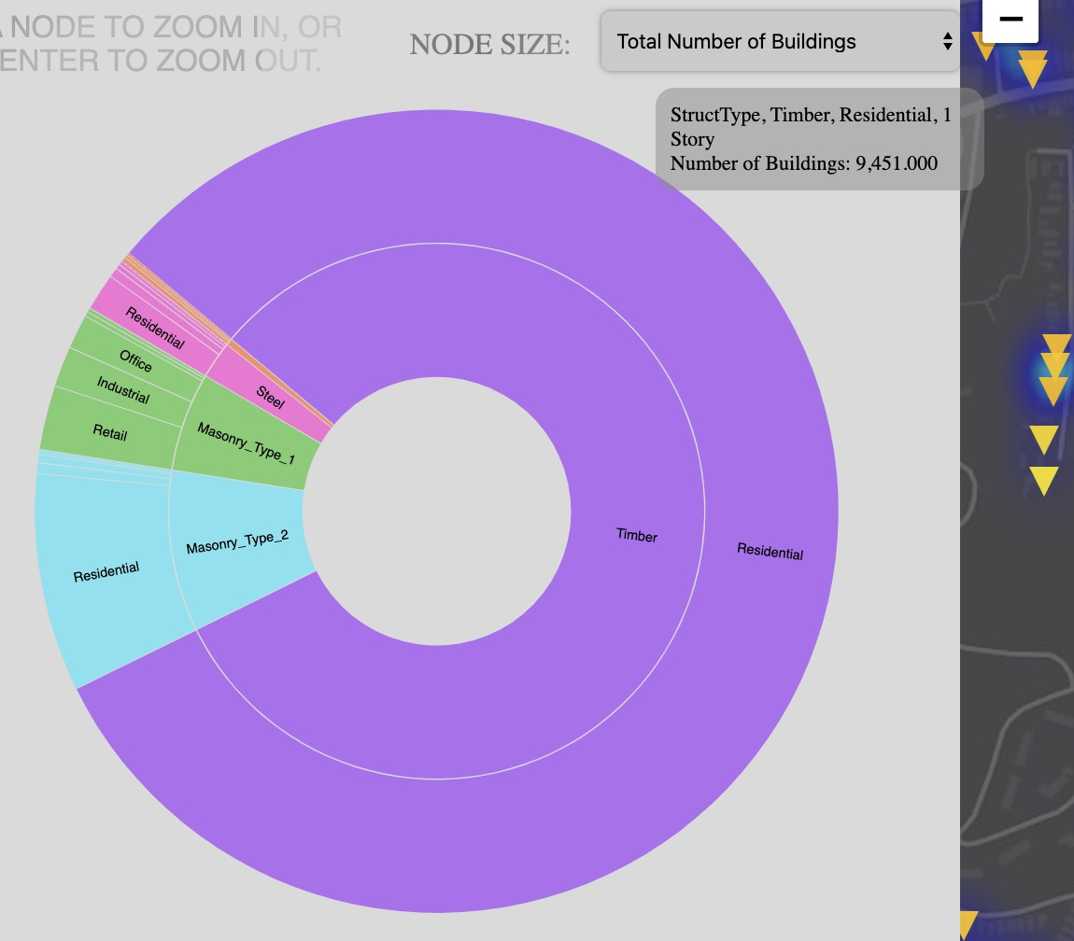

The sunburst v2 takes care of the interactivity with the Map.

With the help of the dropdown you can select the columnar data you want to see.

Also, when you click on one of the types of value, the value of the Map gets updated.

Final version

The ultimate version of the visualization contains the tabs, for making it intuitive and easier for an onlooker to understand what’s going on.

About tab contains a brief introduction about the project members and their current academic standings and career interests.

Help tab is useful when someone is confused so as to what denotes what. He/she can find her way around by looking at the Help tab and makes it easier to navigate.

Background tab is the information about the Concept, Data and the Motivation behind it.

Home tab is the actual visualization tab. This is the main tab pertaining to the project.

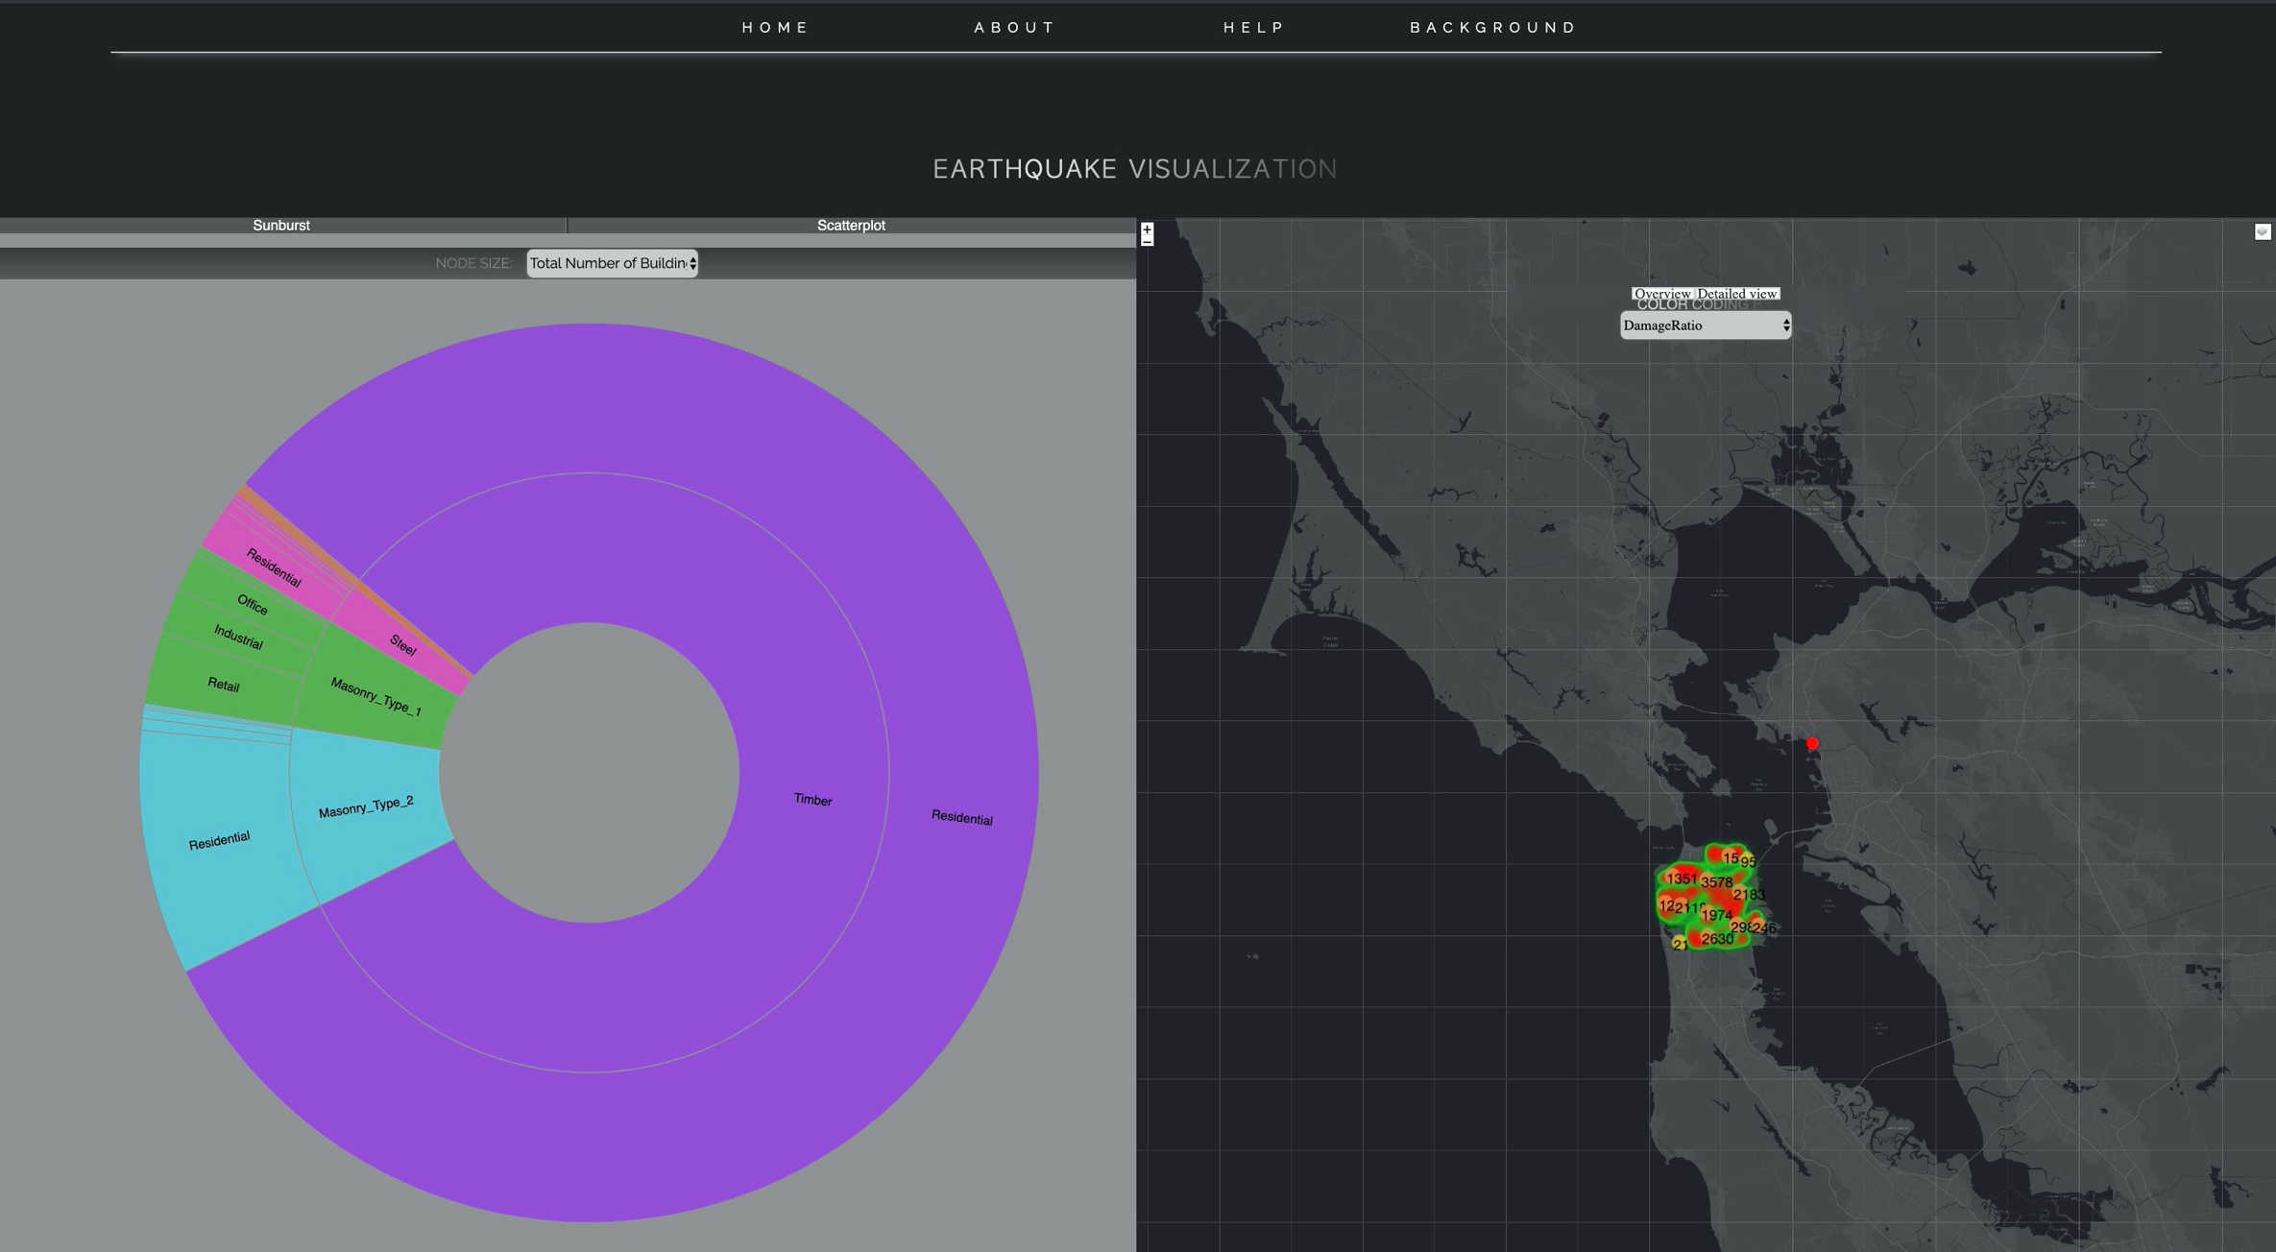

References

* + [1] Rodgers, A. J., Pitarka, A., Petersson, N. A., Sjögreen, B., & McCallen, D. B. (2018). Broadband (0–4 Hz) ground motions for a magnitude 7.0 Hayward fault earthquake with three- dimensional structure and topography. Geophysical Research Letters , 45 (2), 739-747.
  + [2] Wael Elhaddad, Frank McKenna, Mats Rynge, John B. Lowe, Charles Wang, & Adam Zsarnoczay. (2019, February 1). NHERI-SimCenter/WorkflowRegionalEarthquake: rWHALE (Version v1.1.0). Zenodo.

Conclusion and endnotes

Our goal is simply to help the officials and construction companies to make an informed decision so that the building is constructed with the number of stories accordingly.

The areas more prone to earthquake can be marked and extra reinforcement can be added to the foundation of the buildings.

Further, the building can be maintained every quarter annually or checked for any symptoms of weariness and taken care of.



**Thank You**

20